

**Diamond Assessment System**

**Software Requirement Document**

– HCM, Jun 2024 –

Record of changeS

|  |  |  |  |
| --- | --- | --- | --- |
| Date | A* M, D | In charge | Change Description |
| 13/Apr | A | KienNT | Thêm mô tả chức năng Setting Details (II.1.a) |
|  |  |  |  |
|  |  |  |  |
|  |  |  |  |
|  |  |  |  |
|  |  |  |  |
|  |  |  |  |
|  |  |  |  |
|  |  |  |  |
|  |  |  |  |
|  |  |  |  |
|  |  |  |  |

*A - Added M - Modified D - Deleted

**Table of Contents**

I. Overview 5

1. Introduction 5

2. Existing Systems 5

2.1 PNJ Lab 5

2.2 GIV (Gemological Institute of Vietnam) 6

2.3 GIA (Gemological Institute of America) 7

3. Business Process 9

3.1 Receive sample and send back result process 9

3.2 Assessment process 11

4. System Functions 12

5. Entity Relationship Diagram 14

6. State transition diagram 14

II. Functional Requirements 17

1. View Information 17

a. Home Page 17

b. Login 18

c. Assessment Services Page 18

d. Diamond Information Page 20

e. Company Information Page 21

f. Diamond Information Page 22

2. Booking Assessment 24

a. Assessment Booking Page 24

b. Assessment Booking Result 25

c. Diamond Request List 26

d. Request Information Page 27

e. Assessment Receipt Review 28

f. Assessment Result Page and Print Functionality 30

3. Assessment Process 31

a. Assessment Request List for Assessment Staff 31

b. Diamond Attribute Selection Page 31

c. Detailed Information Entry Page 32

d. Cut Specifications Entry Page 33

e. Information Confirm Page 34

f. Information Confirm Page 35

g. Create Assessment Paper Page 36

4. Manage 37

a. User and Role Management Page 37

b. Dashboard Page 38

c. Task Assignment Page 39

III. Database Design 40

1. Database Schema 40

2. Table Detail 41

# I. Overview

## 1. Introduction

The Diamond Assessment System (DAS) is an innovative software solution designed to streamline the entire process of diamond appraisal for a specialized gemological company. This system is expected to be developed software solution that replaces the current manual and fragmented methods used for the appraisal, certification, and management of diamonds. The system is designed to evolve over several releases, with initial functionalities focused on streamlining the internal processes of diamond appraisal, client management, and certificate issuance.

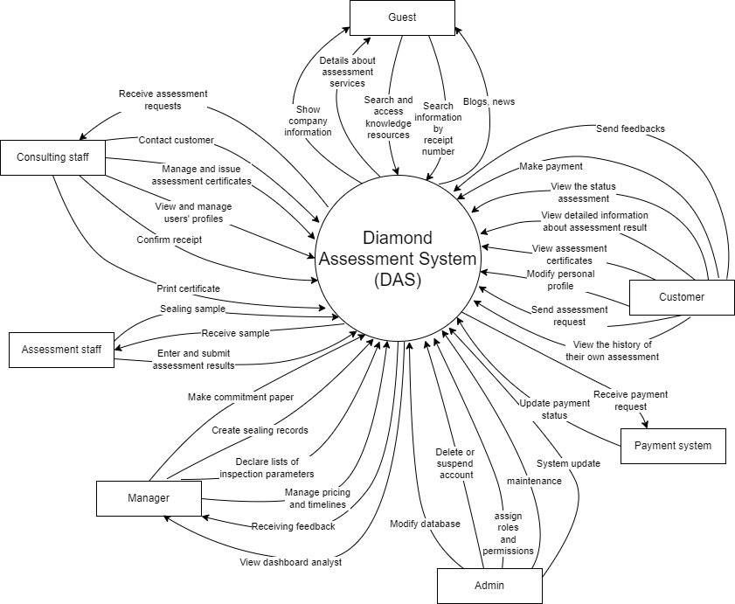>>

## 2. Existing Systems

### 2.1 PNJ Lab

**System Description:** PNJ Lab is a prominent online platform specializing in diamond certification and appraisal. It provides comprehensive services for diamond evaluation, including authenticity checks, quality assessment, and detailed reporting. PNJ Lab caters to both individual customers and businesses, offering professional expertise and advanced technology to ensure accurate and reliable diamond grading.

**System Actors:**

* **Customers:** Individuals and businesses seeking diamond certification and assessment services.
* **Assessment Staff:** Professionals conducting diamond evaluations and preparing detailed reports.
* **Consulting Staff:** Staff assisting customers with inquiries, submissions, and result retrieval.

**Features:**

* **Service Information:** The platform offers detailed descriptions of various diamond certification and appraisal services available.
* **Online Inquiry:** Users can submit diamonds for appraisal through an online request form, specifying their requirements and providing necessary information.
* **Detailed Reports:** PNJ Lab provides comprehensive reports on diamond characteristics, including cut, color, clarity, and carat weight, as well as information on natural versus synthetic origins.
* **Status Tracking:** Customers can track the status of their appraisal requests and receive updates through the platform.

**Pros:**

* **Professional Expertise:** PNJ Lab employs experienced gemologists and utilizes advanced technology to ensure precise and reliable diamond appraisals.
* **Comprehensive Reporting:** The platform provides detailed and transparent reports, covering all essential aspects of diamond evaluation.
* **Customer Support:** Dedicated customer service representatives assist with inquiries and ensure smooth communication throughout the appraisal process.
* **Convenient Access:** Users can easily submit diamonds for appraisal and track their requests online, enhancing convenience and accessibility.

**Cons:**

* **Specialized Focus:** As a platform dedicated to diamond certification and appraisal, PNJ Lab may not offer broader services related to other gemstones or jewelry.
* **Service Limitations:** The availability of certain services and features may be limited based on geographic location or specific customer requirements.

**Overall,** PNJ Lab stands out as a reliable and professional online platform for diamond certification and appraisal, offering a range of services and expert support to meet the needs of both individual customers and businesses in the diamond industry.

### 2.2 GIV (Gemological Institute of Vietnam)

**System Description:** GIV (Gemological Institute of Vietnam) is a leading institution in Vietnam providing comprehensive gemological services, including gemstone certification, appraisal, and education. GIV serves as an authoritative entity in the gemstone industry, offering reliable and precise evaluations for various gemstones and jewelry. The institute caters to individual customers, businesses, and professionals in the gemological field, ensuring high standards and expertise in its services.

**System Actors:**

* **Customers:** Individuals and businesses seeking gemstone certification and appraisal services.
* **Assessment Staff:** Experts conducting detailed evaluations and analyses of gemstones.
* **Educators:** Professionals providing training and educational programs in gemology.
* **Consulting Staff:** Staff assisting customers with inquiries, service requests, and result retrieval.

**Features:**

* **Gemstone Certification:** GIV offers detailed certification services for a wide range of gemstones, including diamonds, rubies, sapphires, and emeralds, providing information on their authenticity and quality.
* **Assessment Services:** The institute conducts professional appraisals to determine the market value of gemstones and jewelry, useful for insurance, sales, or personal knowledge.
* **Educational Programs:** GIV provides educational courses and training in gemology, helping individuals and professionals enhance their knowledge and skills in gemstone identification and evaluation.
* **Online Request Form:** Users can submit gemstones for certification and appraisal through an online form, specifying their needs and providing relevant details.
* **Status Tracking:** Customers can track the progress of their certification or appraisal requests and receive updates through the platform.
* **Comprehensive Reports:** GIV issues detailed reports on gemstone characteristics, including cut, color, clarity, carat weight, and origin, ensuring transparency and reliability.

**Pros:**

* **Expertise and Authority:** GIV is a respected institution in the gemstone industry, known for its high standards and professional expertise.
* **Comprehensive Services:** The platform offers a wide range of services, including certification, appraisal, and education, catering to various needs in the gemological field.
* **Educational Opportunities:** GIV's educational programs help promote knowledge and skills in gemology, benefiting both amateurs and professionals.
* **Convenient Online Access:** The ability to submit requests and track progress online enhances user convenience and accessibility.

**Cons:**

* **Specialized Focus:** As an institution dedicated primarily to gemology, GIV may not provide services related to other aspects of the jewelry industry.
* **Service Limitations:** The availability of specific services and features may be limited based on geographic location or particular customer requirements.

**Overall**, GIV (Gemological Institute of Vietnam) is a reputable and authoritative platform for gemstone certification, appraisal, and education, offering a wide range of services and expert support to meet the diverse needs of customers and professionals in the gemological industry.

### 2.3 GIA (Gemological Institute of America)

**System Description:** GIA (Gemological Institute of America) is an internationally recognized authority in gemology, renowned for its comprehensive diamond grading and education services. The GIA provides detailed evaluations of diamonds and other gemstones, based on the universally accepted 4Cs criteria (Color, Clarity, Cut, and Carat Weight). The platform serves as a critical resource for gem enthusiasts, buyers, sellers, and industry professionals, offering valuable insights and certifications to ensure quality and authenticity.

**System Actors:**

* **Customers:** Individuals and businesses seeking diamond and gemstone certification and education.
* **Assessment** **Staff:** Experts conducting precise and thorough evaluations of diamonds and gemstones.
* **Students:** Individuals enrolled in GIA’s educational programs to learn about gemology.
* **Consulting staff:** Staff assisting customers with inquiries, service requests, and educational guidance.

**Features:**

* **Diamond Grading Reports:** GIA offers comprehensive grading reports that detail the quality and characteristics of diamonds based on the 4Cs criteria.
* **Educational Resources:** The platform provides extensive educational materials, including articles, videos, and courses on gemology, aimed at both beginners and professionals.
* **Online Report Verification:** Users can verify the authenticity of GIA grading reports online, ensuring the integrity of diamond and gemstone evaluations.
* **Gemstone Identification:** The institute conducts precise identification and analysis of a wide range of gemstones, providing information on their origin, treatments, and overall quality.
* **Research and Innovation:** GIA is involved in ongoing research and innovation in gemology, contributing to the development of new techniques and standards in the industry.
* **Interactive Tools:** The platform offers interactive tools, such as the 4Cs guide, which helps users understand the factors that determine a diamond’s quality and value.

**Pros:**

* **Global Authority:** GIA is widely regarded as the leading authority in gemology, known for its rigorous standards and credibility.
* **Comprehensive Education:** The platform offers a wealth of educational resources and programs, helping individuals gain in-depth knowledge and skills in gemology.
* **Trusted Certification:** GIA’s grading reports are highly respected in the industry, providing assurance of quality and authenticity for diamonds and gemstones.
* **Innovative Research:** The institute’s commitment to research and innovation ensures it remains at the forefront of advancements in gemology.

**Cons:**

* **Specialized Focus:** GIA primarily focuses on diamonds and gemstones, which may limit its appeal to those seeking broader jewelry-related services.
* **Cost:** The high standards and international reputation of GIA may result in higher costs for certification and educational programs compared to other providers.

**Overall**, the GIA (Gemological Institute of America) stands as a preeminent platform for diamond and gemstone certification, education, and research, offering unparalleled expertise and resources to meet the needs of gem enthusiasts, industry professionals, and students worldwide.

## 3. Business Process

### 3.1 Receive sample and send back result process

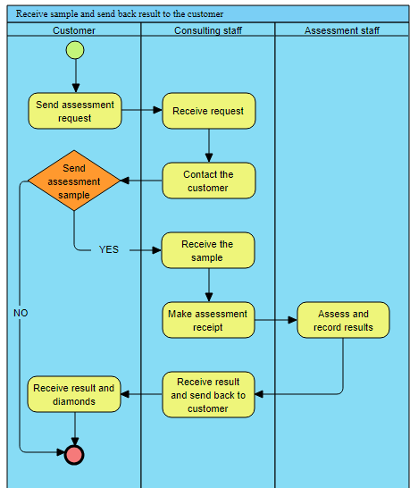

|  |  |  |
| --- | --- | --- |
| **#** | **Process Step** | **Description** |
| 1 | Send assessment request | Customers send request to system for assessment |
| 2 | Receive request | Consulting staff receive customer’s request |
| 3 | Contact the customer | Consulting staff contact customers to have more information about their diamond |
| 4 | Send assessment sample | Customer send diamond to company to assessment, if not, cancel the request |
| 5 | Receive the sample | Consulting staff confirm received diamond |
| 6 | Make assessment receipt | Consulting staff draff the receipt and send so assessment staff |
| 7 | Assess and record result | Assessment staff start assessing and record results then send to consulting staff |
| 8 | Receive result and send back to customer | Consulting staff receive result and send to customer |
| 9 | Receive result and diamond | Customer receive diamond and result |

### 3.2 Assessment process

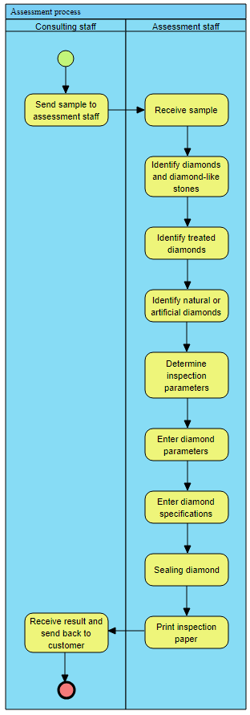

|  |  |  |
| --- | --- | --- |
| **#** | **Process Step** | **Description** |
| 1 | Send sample to assessment staff | Consulting staff send diamond to assessment staff to assess |
| 2 | Receive sample | Assessment staff records the receipt of the diamond in the system and prepares for assessing |
| 3 | Identify diamonds and diamond-like stones | Assessment staff use specialized tools to distinguish genuine diamonds from similar synthetic or natural look-alikes |
| 4 | Identify treated diamonds | The diamonds are examined for any treatments or enhancements that could affect their value |
| 5 | Identify natural or artificial diamonds | Using spectroscopy and other methods, assessment staff determine whether the diamond is natural or lab-created |
| 6 | Determine inspection parameters | Assessment staff establish the specific parameters (Appraisal number, Date of Issue, diamond origin, Shape & Cut, Measurements, Carat weight, Color, Clarity, Cut, Proportions, Polish, Symmetry, Flourescence) to be measured |
| 7 | Enter diamond parameters | The measured parameters of the diamond are accurately entered into the DAS |
| 8 | Enter diamond specifications | Information about diamond is recorded and prepared to create inspection paper |
| 9 | Sealing diamond | The diamond is securely sealed to prevent tampering before certification |
| 10 | Print inspection paper | An official assessment report or certificate is generated and printed from the DAS |
| 11 | Receive result and send back to customer | The completed assessment report and the sealed diamond are returned to the customer, completing the assessment process. |

## 4. System Functions

#### a. Screen Flow

**Customers’ Screen Flow**

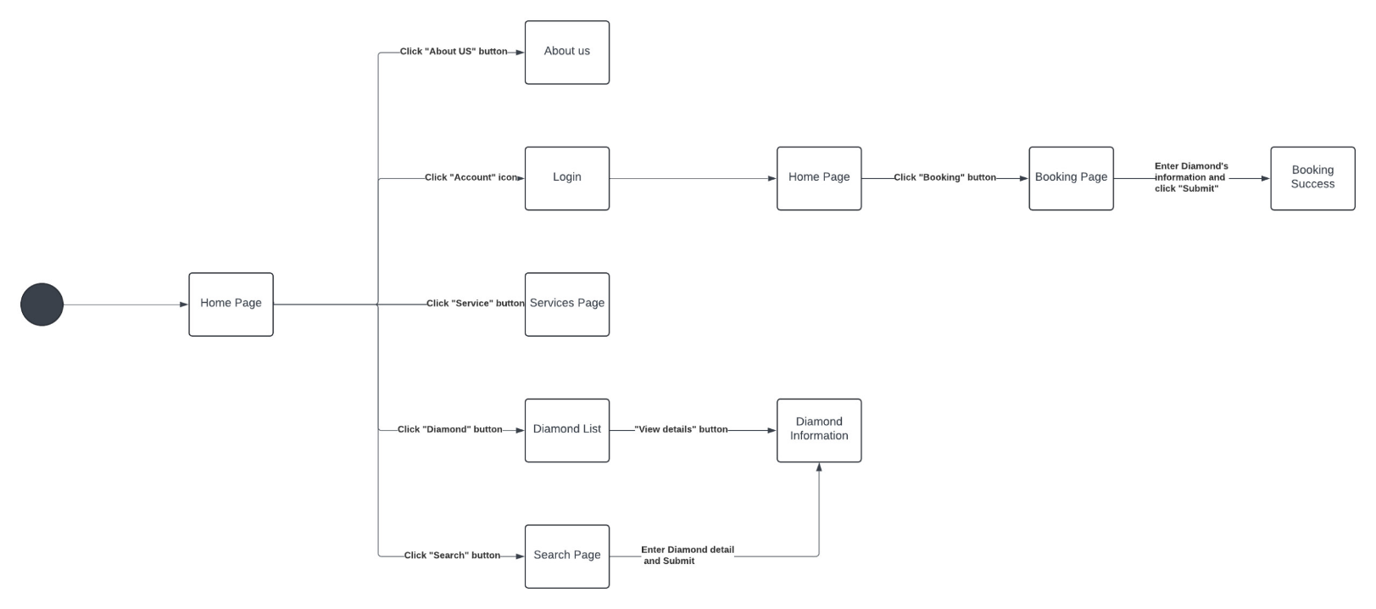

**Consulting Staffs’ Screen Flow**

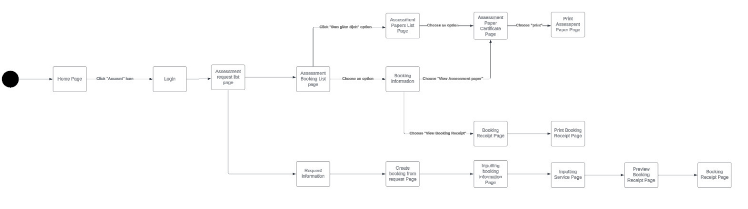

Assessment Staffs’ Screen Flow

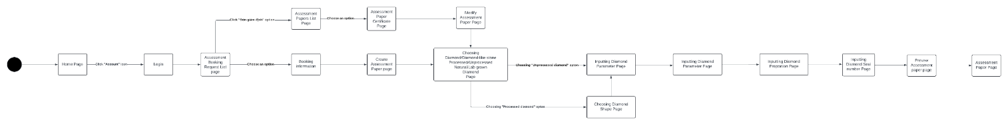

#### b. Screen Details

|  |  |  |  |
| --- | --- | --- | --- |
| **#** | **Feature** | **Screen** | **Description** |
| 1 | View information | Home Page | Displays an introduction to the diamond appraisal company, services offered, diamond knowledge, search, blog, etc. |
| 2 | View information | About Us | Provides detailed information about the company, its mission, and its team. |
| 3 | Login | Login | Allows users to log into their accounts. |
| 4 | View information | Services Page | Lists the different appraisal services provided by the company. |
| 5 | View information | Diamond List | Displays a list of diamonds available for appraisal. |
| 6 | View information | Search Page | Allows users to search for diamond appraisal certificates issued by the company. |
| 7 | View information | Diamond Information | Provides detailed information about a specific diamond. |
| 8 | Assessment Booking | Booking Page | Page where customers can book an appraisal service. |
| 9 | Assessment Booking | Booking Success | Confirmation page displayed after successfully booking an appraisal. |
| 10 | View information | Assessment Request List Page | Displays a list of assessment requests made by the user. |
| 11 | View information | Assessment Paper List Page | Displays a list of assessment papers issued. |
| 12 | View information | Booking Information | Provides detailed information about a specific booking. |
| 13 | View information | Assessment Paper Certificate Page | Displays the details of an assessment paper certificate. |
| 14 | View information | Booking Receipt Page | Displays the receipt of the booking. |
| 15 | View information | Request Information Page | Provides detailed information about a specific assessment request. |
| 16 | Input | Input booking information page | Allows input of booking information. |
| 17 | Input | Input Service Page | Allows input of service details for appraisal services. |
| 18 | Preview | Preview Booking Receipt Page | Allows preview of the booking receipt before final submission. |
| 19 | Assess | Assessment Execution Page | Page where the assessor carries out the appraisal process. |
| 20 | Create | Create Assessment Paper Page | Allows creation of an assessment paper. |
| 21 | Choosing | Choosing Attribute Page | Allows selection of attributes for the diamond appraisal. |
| 22 | Input | Input Diamond Parameter Page | Page to input specific diamond parameters. |
| 23 | Choosing | Choosing Shape | Allows selection of the shape of the diamond. |
| 24 | Input | Input Proportion Page | Page to input the proportions of the diamond. |
| 25 | Input | Input Seal Number | Allows input of the seal number for the diamond appraisal. |

#### c. User Authorization

|  |  |  |  |  |  |  |
| --- | --- | --- | --- | --- | --- | --- |
| **Screen** | **Admin** | **Manager** | **Customer** | **Guest** | **Assessment Staff** | **Consulting Staff** |
| Home Page | X | X | X | X | X | X |
| About Us | X | X | X | X | X | X |
| Login | X | X | X |  | X | X |
| Services Page | X | X | X | X | X | X |
| Diamond List | X | X | X | X | X | X |
| Search Page | X | X | X | X | X | X |
| Diamond Information | X | X | X | X | X | X |
| Booking Page | X | X | X |  | X | X |
| Booking Success | X | X | X |  | X | X |
| Assessment Request List Page | X | X |  |  | X | X |
| Assessment Paper List Page | X | X |  |  | X | X |
| Booking Information | X | X |  |  | X | X |
| Assessment Paper Certificate Page | X | X |  |  | X | X |
| Booking Receipt Page | X | X |  |  | X | X |
| Request Information Page | X | X |  |  | X | X |
| Input booking information page | X | X |  |  | X | X |
| Input Service Page | X | X |  |  | X | X |
| Preview Booking Receipt Page | X | X |  |  | X | X |
| Assessment Execution Page | X | X |  |  | X |  |
| Create Assessment Paper Page | X | X |  |  | X |  |
| Choosing Attribute Page | X | X |  |  | X |  |
| Input Diamond Parameter Page | X | X |  |  | X |  |
| Choosing Shape | X | X |  |  | X |  |
| Input Proportion Page | X | X |  |  | X |  |
| Input Seal Number | X | X |  |  | X |  |
| Commitment Paper Page | X | X |  |  | X | X |
| Manage Service Price List Page | X | X |  |  |  | X |
| Declare Appraisal Parameters Page | X | X |  |  | X | X |
| Dashboard Page | X | X |  |  | X | X |

In which:

* **Admin**: Full access to all features and functionalities. Can manage users, services, bookings, and assessments.
* **Manager**: Access to most management features, including overseeing bookings and assessments, but with some restrictions compared to Admin.
* **Customer**: Can book assessments, view their bookings and results, and manage their account. No access to management features.
* **Guest**: Can view general information about the company and services but cannot interact with the booking or assessment processes.
* **Assessment** **Staff**: Responsible for the technical assessment of diamonds. Can access and input data relevant to assessments.
* **Consulting** **Staff**: Handles customer consultations, booking management, and administrative tasks related to assessments.

## 5. Entity Relationship Diagram

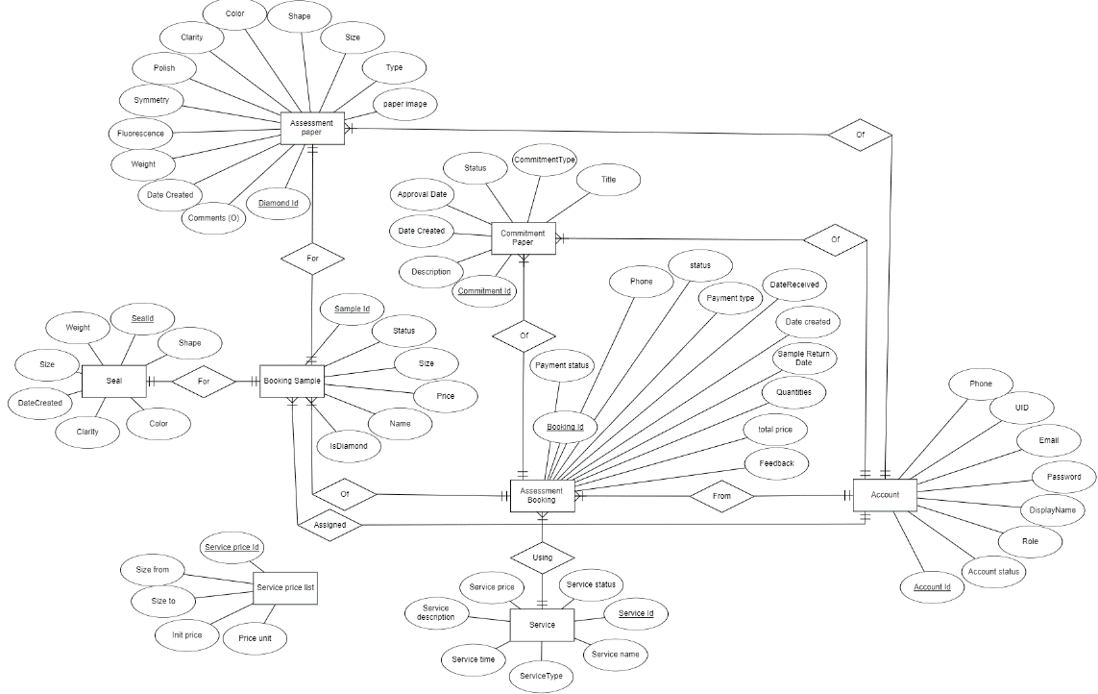

**Entities Description**

|  |  |  |
| --- | --- | --- |
| **#** | **Entity** | **Description** |
| 1 | Account | Stores user account details, including personal information and authentication tokens. |
| 2 | Seal | Records details of the sealing process for diamonds. |
| 3 | Assessment Booking | Stores details about customers’ booking for assessment services. |
| 4 | Assessment Paper | Contains detailed assessment information for each sample. |
| 5 | Booking Detail | Stores details of booking samples made by customers |
| 6 | Commitment Paper | Records commitment papers related to assessment bookings |
| 7 | Service Price List | Stores the price list for different services offered. |
| 8 | Service | Stores details of services offered for diamond assessment |

## 6. State transition diagram

Assessment Request:

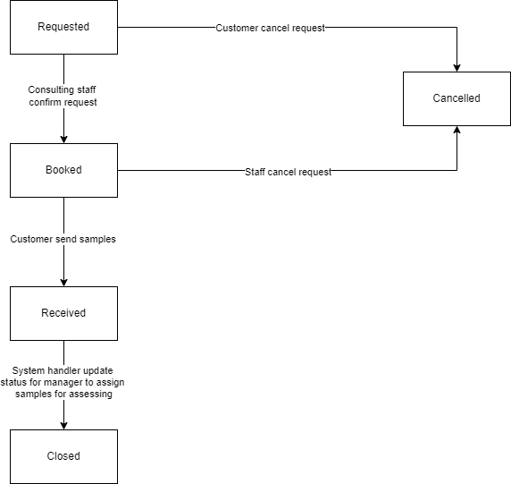

Assessment Booking:

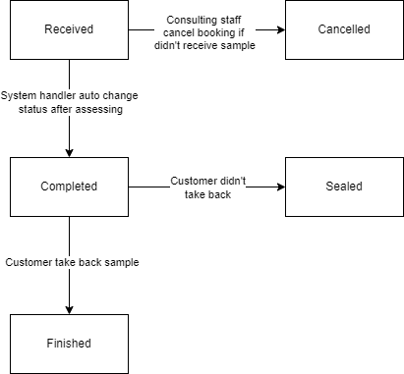

Assessment Booking Detail:

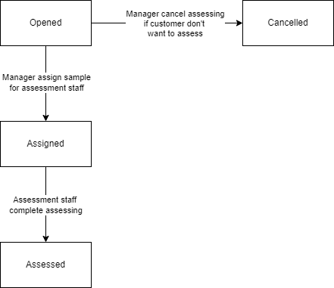

# II. Functional Requirements

## 1. View Information

### a. Home Page

**Function Trigger:** Automatically displayed upon successful login or when the user navigates to the home URL.

**Function Description:**

* **Actors/Roles:** User, System.
* **Purpose:** Provide users with a central hub for accessing system features and information.
* **Interface:** Main navigation menu, dashboard or overview of key features, personalized content.
* **Data Processing:** Retrieve and display relevant user data, aggregate and present system information.

****Screen layout:**

**Function Details:**

* **Feature Accessibility:** Provide links or buttons to access different sections or features of the system.
* **Functionality:** Enable quick access to features, such as assessment booking, searching, view information or manage account.

### b. Login

**Function Trigger:** User click on Account logo on top-right of the page

**Function Description:**

* **Actors/Roles:** User, System.
* **Purpose:** Authenticate user identity for system access.
* **Interface:** Login with Google
* **Data Processing:** Validate input, authenticate credentials, manage sessions.

**Screen layout:**

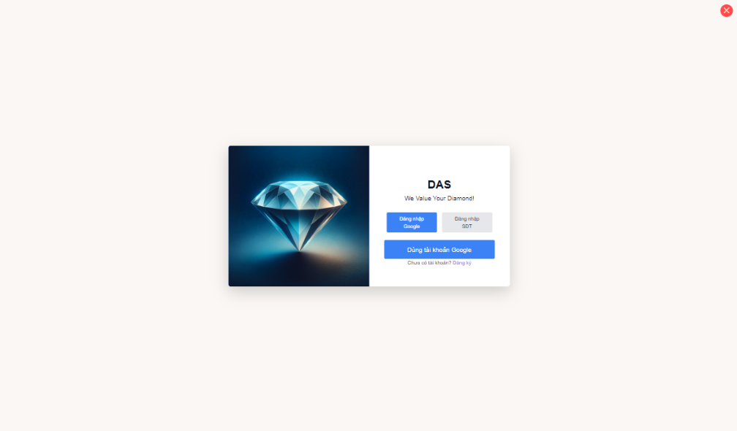

**Function Details:**

* **Business Logic:** Verify credentials against database, handle incorrect entries.

### c. Assessment Services Page

**Function Trigger:** Accessed when users navigate to the Service button on the header of the platform.

**Function Description:**

* **Actors/Roles:** Users, Administrators.
* **Purpose:** Provide information about the services offered by the platform.
* **Interface:** Service listing with descriptions, pricing, and any additional details, possibly categorized for easy navigation.
* **Data Processing:** Presentation of service details retrieved from the database, potentially allowing users to filter or search for specific services.

**Screen layout:**

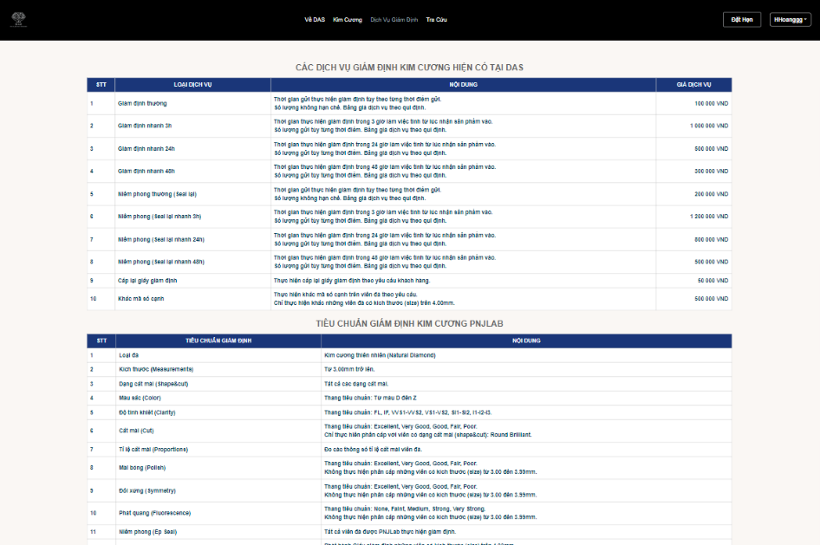

**Function Details:**

* **Data Presentation:** Display detailed information about each service, including its features, benefits, and any limitations.
* **Search Functionality:** Allow users to search for specific services by keyword.
* **Filtering and Sorting:** Enable users to refine their search results based on various criteria, enhancing the browsing experience.
* **Accessibility:** Ensure that service details are accessible and comprehensible to all users, regardless of their level of familiarity with the platform**.**

### d. Diamond Information Page

**Function Trigger:** Accessed when users navigate to the Search button section on the header of the platform.

**Function Description:**

* **Actors/Roles:** Users, Administrators.
* **Purpose:** Enable users to search for diamonds based on specific criteria.
* **Interface:** Search form with filters for diamond attributes such as carat weight, cut, color, clarity, and price range.
* **Data Processing:** Querying the database to retrieve diamonds that match the user's search criteria and presenting the results.

**Screen layout:**

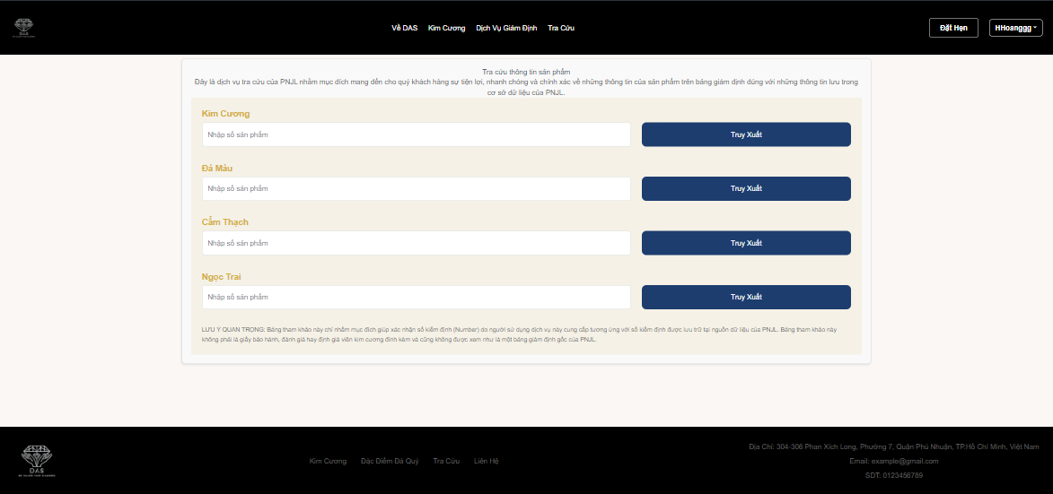

* **Function Details:**
* **Data Retrieval:** Query the database to fetch diamonds that meet the specified search criteria.
* **Filtering and Sorting:** Allow users to apply filters and sorting options to narrow down their search results and find diamonds that best fit their requirements.
* **Preview Functionality:** Provide thumbnail images and basic information about each diamond in the search results to help users make informed decisions.
* **User Interaction:** Allow users to interact with search results (e.g., view detailed information, add to favorites, compare with other diamonds).

### e. Company Information Page

**Function Trigger:** Accessed when users navigate to the “About DAS” on header of platform.

**Function Description:**

* **Actors/Roles:** Users, Administrators.
* **Purpose:** Provide comprehensive information about the company, its mission, values, history, and contact details.
* **Interface:** Structured layout with sections for different aspects of company information.
* **Data Processing:** Presentation of company information retrieved from a content management system.

**Screen layout:**

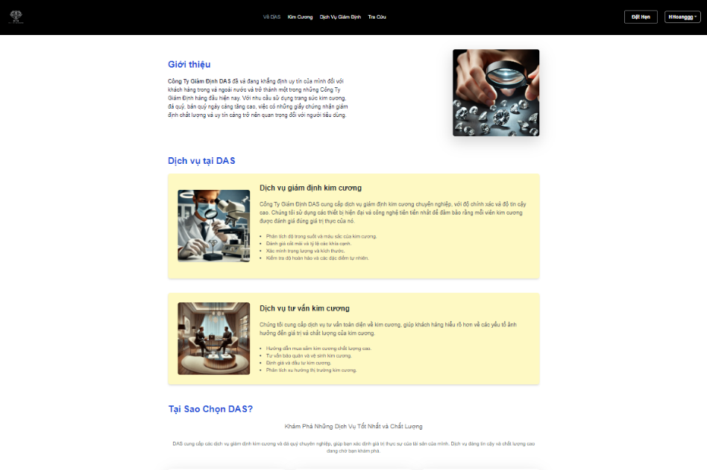

**Function Details:**

* **Content Presentation:** Display company information in a clear and organized manner to enhance user understanding.
* **Interactivity:** Provide options for users to interact with the company (e.g., contact form, links to social media).
* **Accessibility:** Ensure that all users, regardless of their background or abilities, can easily access and understand the company information.
* **Update Capability:** Allow administrators to update company information as needed to keep it current and relevant.

### f. Diamond Information Page

**Function Trigger:** Accessed when users navigate to the “Diamond” on the header or choose an diamond after searching.

**Function Description:**

* **Actors/Roles:** Users, Administrators.
* **Purpose:** Provide detailed information about diamonds, including their characteristics, grading, and purchasing guidance.
* **Interface:** Structured layout with sections for different aspects of diamond information.
* **Data Processing:** Presentation of diamond information retrieved from reputable sources or industry experts.

**Screen layout:**

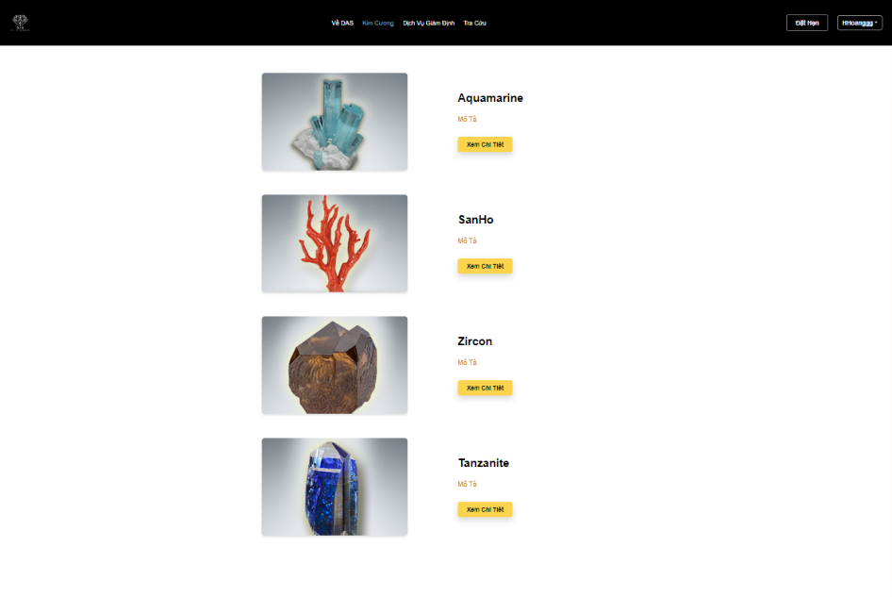

**Function Details:**

* **Comprehensive Information:** Provide detailed and accurate information about diamonds to educate users and help them make informed decisions.
* **Visual Aids:** Include images, diagrams, and videos to enhance understanding of diamond characteristics and grading.
* **User Engagement:** Allow users to interact with the content (e.g., through quizzes, interactive tools) to deepen their knowledge.
* **Trustworthiness:** Source information from reputable sources or industry experts to ensure reliability and credibility.

## 2. Booking Assessment

### a. Assessment Booking Page

**Function Trigger:** Accessed when customer navigate to the diamond assessment service booking page via URL or link on the main website.

**Function Description:**

* **Actors/Roles:** Customer, System.
* **Purpose:** Provide an interface for customers to schedule appointments for their diamond assesses.
* **Interface:** Appointment booking form with fields such as name, phone number, address, services and number of samples.
* **Data Processing:** Send notification for consulting staff to setup an appointment with customer.

**Screen layout:**

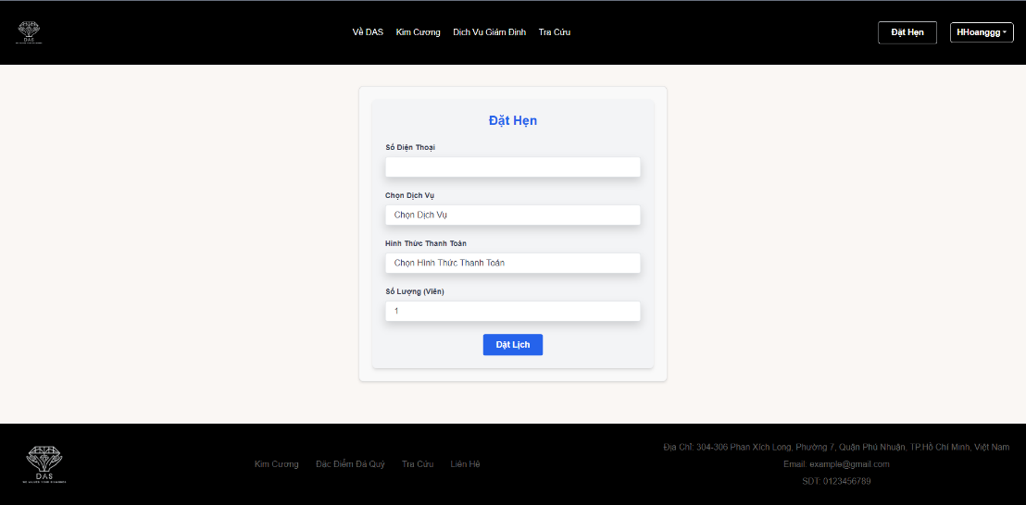

**Function Details:**

* **Data Validation:** Ensure completeness and accuracy of user-entered information.
* **Functionalities:**
  + Allow users to select assessment types and preferred dates.
  + Assign appointments based on availability and service requirements.
  + Send confirmation details to users via email or messaging.

### b. Assessment Booking Result

**Function Trigger:** Accessed after the customer completes the booking process and click Submit.

**Function Description:**

* **Actors/Roles:** Customer, Consulting Staff.
* **Purpose:** Confirm the successful booking of a service requested by the customer.
* **Interface:** Confirmation page displaying details of the booked service, including date, time, and any additional instructions.
* **Data Processing:** Validation of booking details, updating the booking status in the system.

**Screen layout:**

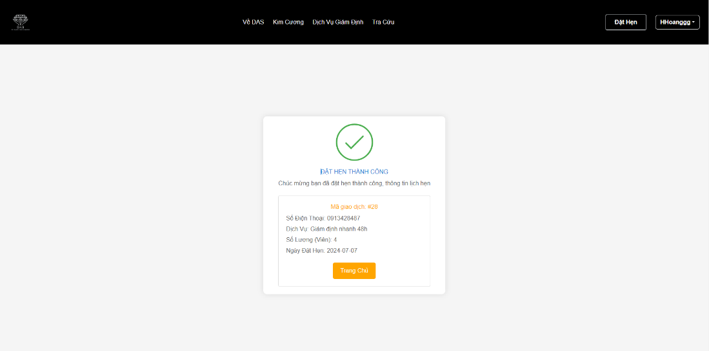

**Function Details:**

* **Data Validation:** Ensure all necessary booking details are complete and accurate**.**
* **Business Logic:** Update the booking status in the system to 0.
* **Functionalities:**
  + Provide a clear confirmation message to the customer, reassuring them that their booking request has been received and processed.
  + Display relevant details of the booked service for the customer's reference.

### c. Assessment Request List

**Function Trigger:** Accessed when consulting staff log in to their accounts or navigate to the diamond request section.

**Function Description:**

* **Actors/Roles:** Consulting Staff, Administrators.
* **Purpose:** Provide consulting staff with a list of diamond requests made by customers.
* **Interface:** List layout displaying relevant details of each diamond request.
* **Data Processing:** Retrieval of diamond request information from the database and presentation in a user-friendly format.

**Screen layout:**

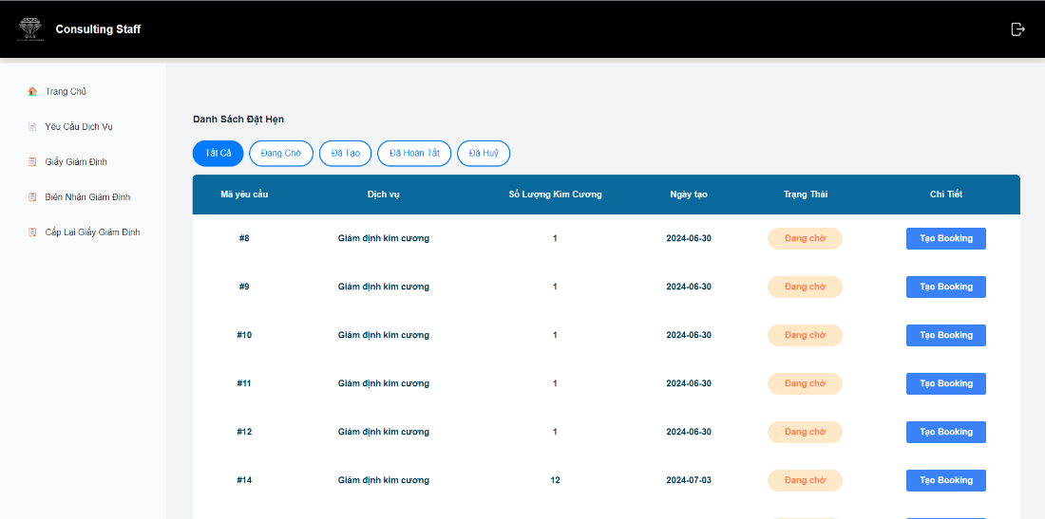

**Function Details:**

* **Data Display:** Present relevant details of each diamond request in a clear and organized manner for easy reference by consulting staff.
* **Status Tracking:** Display the current status of each request (e.g., pending, in progress, completed) to track the progress of diamond consultations.
* **Actionable Items**: Allow consulting staff to view more details about each request and update its status as needed (e.g., marking it as in progress or completed).
* **Filtering and Sorting:** Provide options for filtering and sorting the request list based on various criteria (e.g., status, customer name, date submitted) to facilitate efficient management.

### d. Request Information Page

**Function Trigger:** Accessed when consulting staff click on a specific request from the Diamond Request List.

**Function Description:**

* **Actors/Roles:** Consulting Staff, Administrators.
* **Purpose:** Provide comprehensive details about a specific diamond request made by a customer.
* **Interface:** Detailed layout displaying all relevant information related to the request.
* **Data Processing:** Retrieval and presentation of detailed request information from the database.

**Screen layout:**

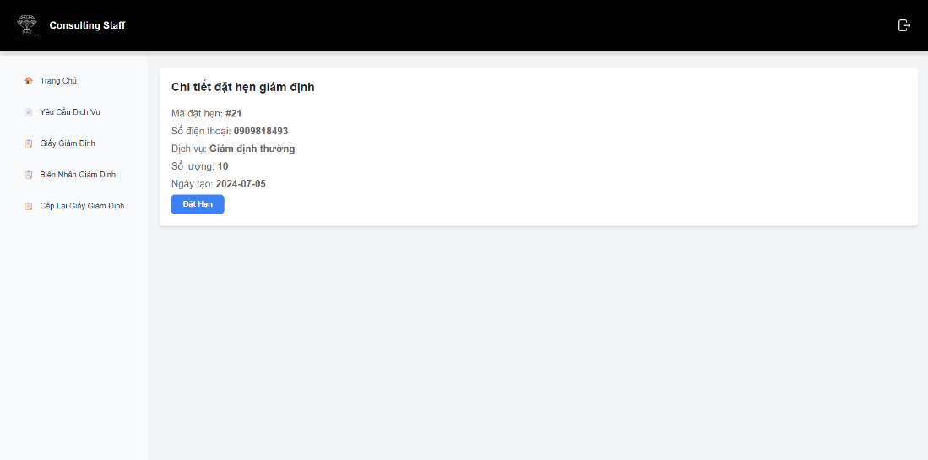

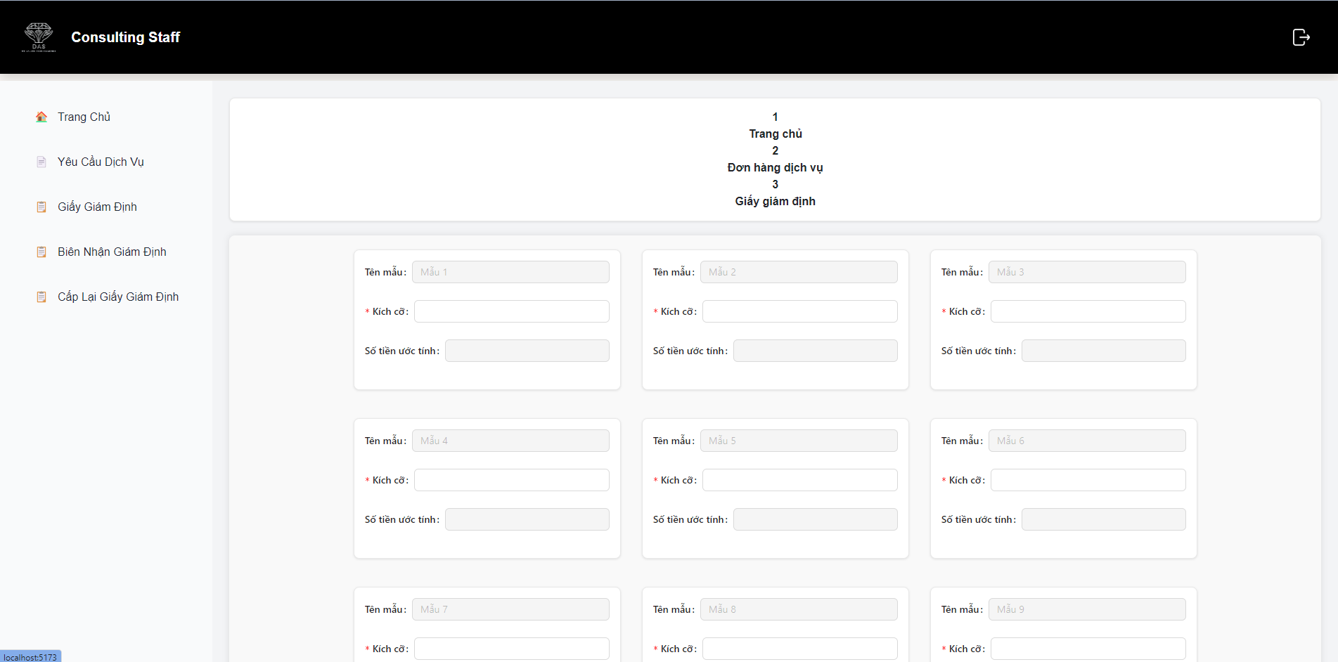

**Function Details:**

* **Comprehensive Information:** Display all relevant details about the request to provide consulting staff with a complete understanding of the customer's requirements.
* **Actionable Items:** Allow consulting staff to update the status of the request (e.g., marking it as in progress or completed) and add notes to document any relevant information or updates.
* **Visibility of Status:** Clearly indicate the current status of the request to track its progress and ensure timely follow-up.
* **User-Friendly Interface:** Present the information in a user-friendly layout that is easy to navigate and understand.

### e. Assessment Receipt Review

**Function Trigger:** Accessed when consulting staff click on a specific assessment receipt from the list of assessments.

**Function Description:**

* **Actors/Roles:** Consulting Staff, Administrators.
* **Purpose:** Provide consulting staff with a detailed view of an assessment receipt for review and the option to print it if needed.
* **Interface:** Detailed layout displaying all relevant information related to the assessment receipt.
* **Data Processing:** Retrieval and presentation of detailed assessment receipt information from the database.

**Screen layout:**

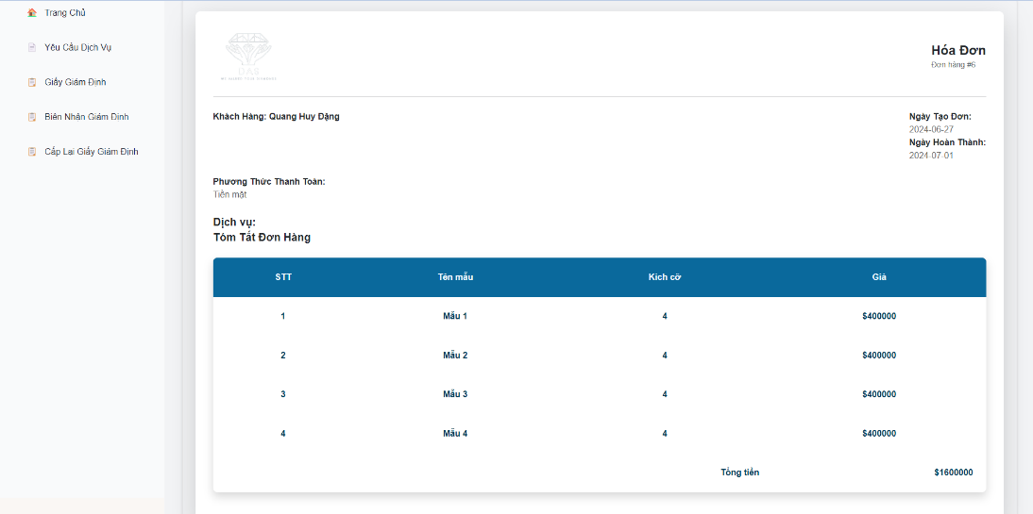

**Function Details:**

* **Comprehensive Information**: Display all relevant details about the assessment receipt to provide consulting staff with a complete overview of the assessment.
* **Print Option:** Provide a convenient option for consulting staff to print the assessment receipt for record-keeping or customer delivery purposes.
* **Payment Status:** Clearly indicate the payment status of the assessment to track financial transactions and ensure proper documentation.
* **User-Friendly Interface:** Present the information in a clear and organized layout that is easy to read and navigate.

### f. Assessment Result Page and Print Functionality

**Function Trigger:** Accessed when consulting staff select a specific assessment from the list of assessments.

**Function Description:**

* **Actors/Roles:** Consulting Staff, Administrators.
* **Purpose:** Provide consulting staff with a detailed view of an assessment result and the option to print it.
* **Interface:** Detailed layout displaying all relevant information related to the assessment result.
* **Data Processing:** Retrieval and presentation of detailed assessment result information from the database.

**Screen layout:**

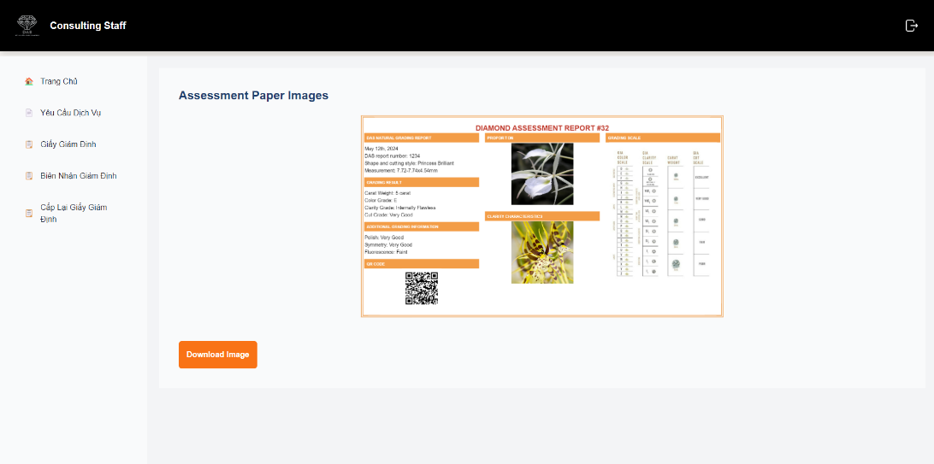

**Function Details:**

* **Comprehensive Information:** Display all relevant details about the assessment result to provide consulting staff with a complete understanding of the assessment outcome.
* **Print Option:** Provide a convenient option for consulting staff to print the assessment result for record-keeping or customer delivery purposes.
* **User-Friendly Interface:** Present the information in a clear and organized layout that is easy to read and navigate.
* **Print Functionality:** Allow consulting staff to print the assessment result with a single click using the provided print button.

## 3. Assessment Process

### a. Assessment Request List for Assessment Staff

**Function Trigger:** Accessed when assessment staff log in to their accounts or navigate to the assessment request section.

**Function Description:**

* **Actors/Roles:** Assessment Staff, Administrators.
* **Purpose:** Provide assessment staff with a comprehensive list of assessment requests submitted by customers.
* **Interface:** List layout displaying relevant details of each assessment request.
* **Data Processing:** Retrieval and presentation of assessment request information from the database.

**Screen layout:**

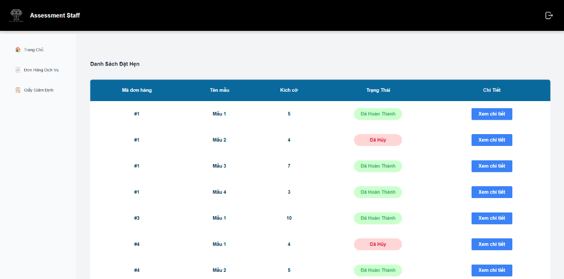

**Function Details:**

* **Data Display:** Present relevant details of each assessment request in a clear and organized manner for easy reference by assessment staff.
* **Status Tracking:** Display the current status of each request (e.g., pending, in progress, completed) to track the progress of assessments.
* **Actionable Items:** Allow assessment staff to view more details about each request and update its status as needed (e.g., marking it as in progress or completed).
* **Filtering and Sorting**: Provide options for filtering and sorting the request list based on various criteria (e.g., status, customer name, date submitted) to facilitate efficient management.

### b. Diamond Attribute Selection Page

**Function Trigger:** Accessed when assessment staff choose an request to fill information after assessing.

**Function Description:**

* **Actors/Roles:** Assessment Staff, Administrators.
* **Purpose:** Enable assessment staff to select and input detailed diamond attributes for an assessment request.
* **Interface:** Form layout with fields for entering various diamond characteristics and additional details.
* **Data Processing:** Input validation and submission of diamond attribute details to the database.

**Screen layout:**

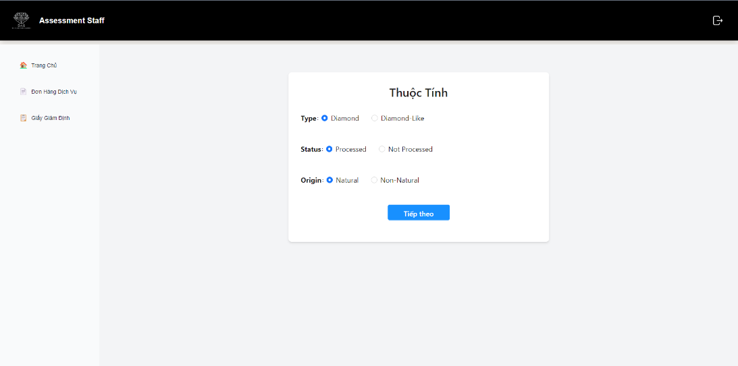

**Function Details:**

* **Input Validation:** Ensure that all required fields are filled out and that the data entered is within acceptable ranges.
* **User-Friendly Interface:** Provide dropdown menus for standard diamond attributes to minimize input errors and ensure consistency.
* **Auto-Fill Information:** Auto-fill relevant information such as Request ID and Customer Name based on the selected assessment request to reduce manual data entry.
* **Save Functionality:** Allow assessment staff to save the entered diamond attributes to the database for the specific assessment request.

### c. Detailed Information Entry Page

**Function Trigger:** Accessed after assessment staff finish choosing diamond attribute.

**Function Description:**

* **Actors/Roles:** Assessment Staff, Administrators.
* **Purpose:** Enable assessment staff to enter and update detailed information about the diamond being assessed.
* **Interface:** Form layout with fields for entering various diamond characteristics, assessment results, and additional comments.
* **Data Processing:** Input validation, data submission to the database, and updating of the assessment status.

**Screen layout:**

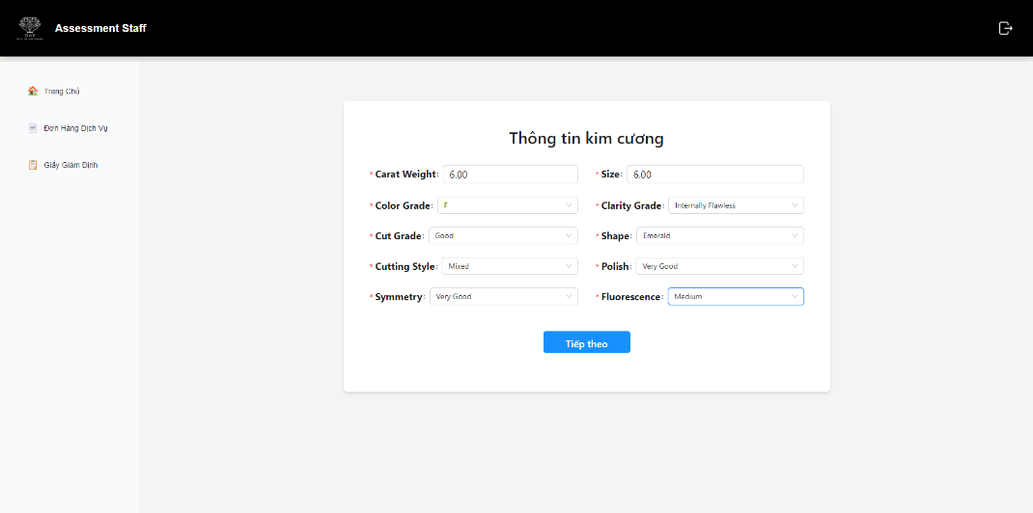

**Function Details:**

* **Comprehensive Information Entry:** Allow assessment staff to enter all relevant details about the diamond in a structured manner.
* **Input Validation:** Ensure all required fields are filled out and data entered is within acceptable ranges to maintain data integrity.
* **User-Friendly Interface:** Provide dropdown menus for standard diamond attributes and auto-fill functionality for request and customer details to minimize errors and speed up data entry.
* **Save and Update Functionality:** Enable saving of the entered data to the database and updating the assessment status as the process progresses.

### d. Cut Specifications Entry Page

**Function Trigger:** Accessed after assessment staff finish entering detailed information.

**Function Description:**

* **Actors/Roles:** Assessment Staff, Administrators.
* **Purpose:** Enable assessment staff to enter and update detailed cut specifications for the diamond being assessed.
* **Interface:** Form layout with fields for entering various cut parameters, such as proportions and measurements.
* **Data Processing:** Input validation, data submission to the database, and updating of the assessment status.

**Screen layout:**

**

**Function Details:**

* **Comprehensive Information Entry:** Allow assessment staff to enter all relevant cut specifications in a structured manner.
* **Input Validation:** Ensure all required fields are filled out and data entered is within acceptable ranges to maintain data integrity.
* **User-Friendly Interface**: Provide dropdown menus for standard cut parameters and auto-fill functionality for request and customer details to minimize errors and speed up data entry.
* **Save and Update Functionality:** Enable saving of the entered data to the database and updating the assessment status as the process progresses.

### e. Information Confirm Page

**Function Trigger:** Accessed after assessment staff finish entering Cut Specifications.

**Function Description:**

* **Actors/Roles:** Assessment Staff, Administrators.
* **Purpose:** Allow assessment staff to review and confirm all entered information before final submission.
* **Interface:** Summary layout displaying all previously entered information with options to confirm or go back for editing.
* **Data Processing:** Display entered data, allow for final review, and confirm submission to the database.

**Screen layout:**

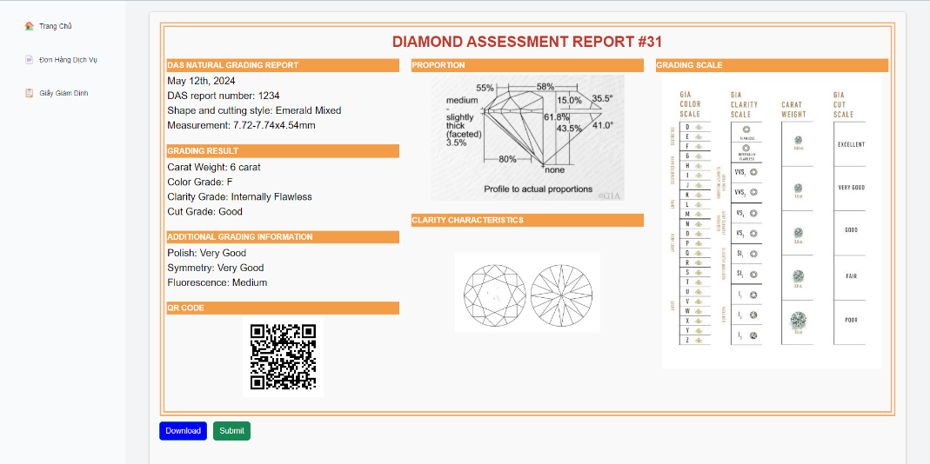

**Function Details:**

* **Review Functionality:** Display all entered information in a clear, organized manner for final review by assessment staff.
* **Editing Option:** Provide a convenient way to navigate back to the entry form to correct any errors or omissions.
* **Confirmation:** Enable assessment staff to confirm the accuracy of the entered information and submit it to the database.
* **User-Friendly Interface:** Ensure the layout is easy to read and navigate, with clearly labeled sections and action buttons.

### f. Information Confirm Page

**Function Trigger:** Accessed when assessment staff log in to their accounts or navigate to the assessment result section.

**Function Description:**

* **Actors/Roles:** Assessment Staff, Administrators.
* **Purpose:** Provide assessment staff with a comprehensive list of completed assessment results.
* **Interface:** List layout displaying relevant details of each completed assessment.

**Screen layout:**

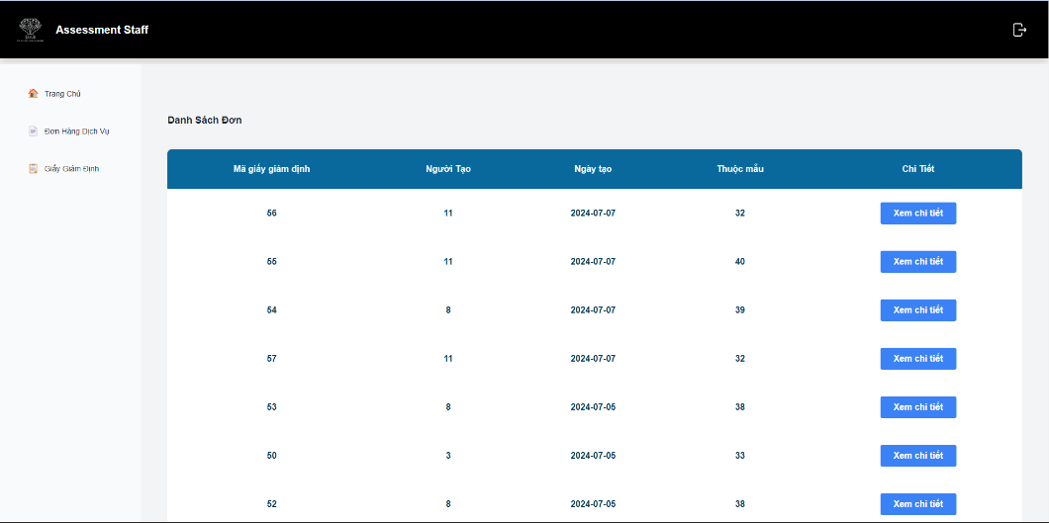

**Function Details:**

* **Data Display:** Present relevant details of each completed assessment in a clear and organized manner for easy reference by assessment staff.
* **Assessment Results:** Display the grading and valuation results for each assessed diamond.
* **Actionable Items:** Allow assessment staff to view more details about each assessment result and print the assessment report if needed.
* **Filtering and Sorting:** Provide options for filtering and sorting the assessment result list based on various criteria (e.g., customer name, assessment date, diamond details) to facilitate efficient management.

**Screen Actions:**

* **View Details Button:** Opens a detailed view of the selected assessment result, showing all the entered information and results.
* **Print Button:** Opens the print dialog to print the detailed assessment result for record-keeping or customer delivery.

### g. Create Assessment Paper Page

**Function Trigger:** Accessed when assessment staff log in to their accounts or navigate to the assessment result section.

**Function Description:**

* **Actors/Roles:** Assessment Staff, Administrators.
* **Purpose:** Enable assessment staff to create a new assessment paper with detailed information about the diamond.
* **Interface:** Form layout with fields for entering diamond attributes, assessment details, and additional comments.
* **Data Processing:** Input validation, data submission to the database, and updating of assessment status.

**Screen layout:**

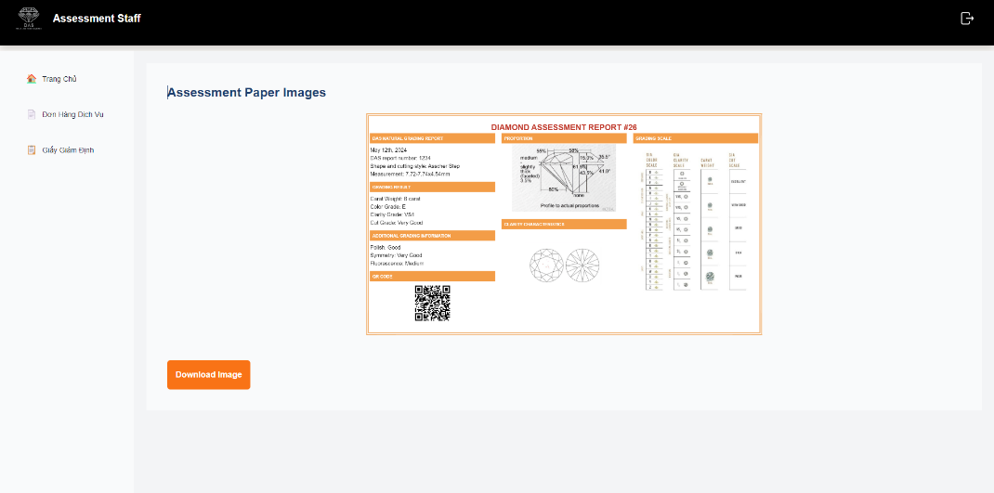

**Function Details:**

* **Comprehensive Information Entry:** Structured entry of all relevant diamond and assessment details.
* **Input Validation:** Ensure all required fields are filled and data is accurate.
* **User-Friendly Interface:** Dropdown menus for standard attributes and auto-fill for request/customer details.
* **Save and Submit:** Save data to the database and submit the assessment paper to update status.

## 4. Manage

### a. User and Role Management Page

**Function Trigger:** Accessed when admin log in to their accounts or navigate to the manage section.

**Function Description:**

* **Actors/Roles:** Administrators.
* **Purpose:** Allow administrators to manage user accounts and assign roles.
* **Interface:** List layout displaying users and their roles, with options to add, edit, or delete users and roles.
* **Data Processing:** Input validation, data submission to the database, and updating of user and role information.

**Screen layout:**

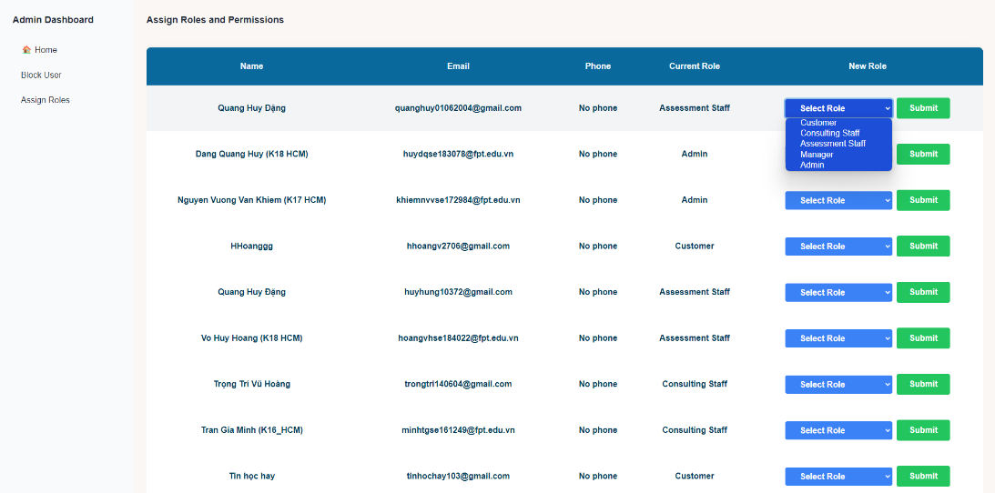

**Function Details:**

* **User Management:**
  + Add/Edit User Form: Username, Email, Password, Role.
  + Validation ensures all fields are filled correctly.
* **Role Management:**
  + Add/Edit Role Form: Role Name, Permissions.
  + Validation ensures unique role name and proper permissions selection.
* **Actionable Items:** Enable administrators to efficiently manage users and roles.
* **Data Integrity:** Ensure validation for accurate and consistent data.

### b. Dashboard Page

**Function Trigger:** Accessed immediately after admin or manager login.

**Function Description:**

* **Actors/Roles:** Admins, Managers.
* **Purpose:** Provide a central platform for admins and managers to monitor and manage system activities.
* **Interface:** Customized dashboard layout with modules tailored to admin and manager roles.
* **Data Processing:** Retrieve and present relevant data regarding system activities, user management, and other administrative tasks.

**Screen layout:**

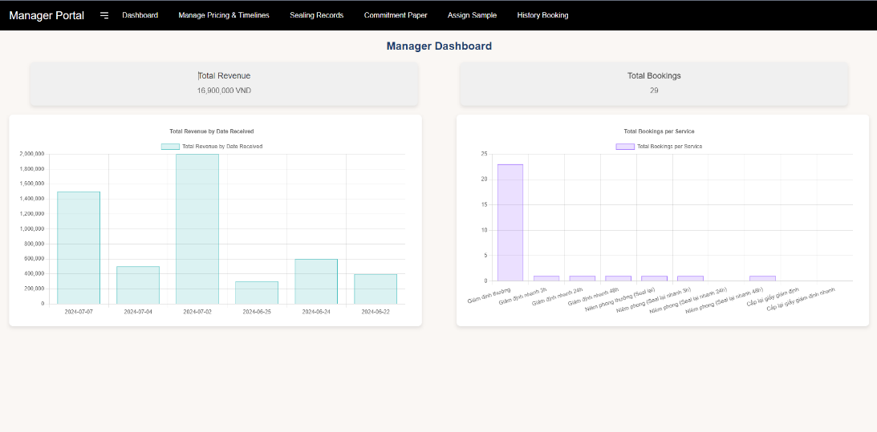

**Function Details:**

* **Role-Based Access**: Only accessible to admins and managers upon login.
* **Customization:** Tailored modules and widgets based on admin and manager responsibilities.
* **Data Visualization:** Present system data and metrics in an easy-to-understand format.
* **Actionable Items:** Enable admins and managers to perform necessary tasks directly from the dashboard.

### c. Task Assignment Page

**Function Trigger:** Accessed when manager log in to their accounts or navigate to the task assignment page.

**Function Description:**

* **Actors/Roles:** Managers.
* **Purpose:** Enable managers to assign tasks to staff members.
* **Interface:** List layout displaying available tasks and staff members with options to assign tasks.
* **Data Processing:** Input validation, data submission to the database, and updating of task assignments.

**Screen layout:**

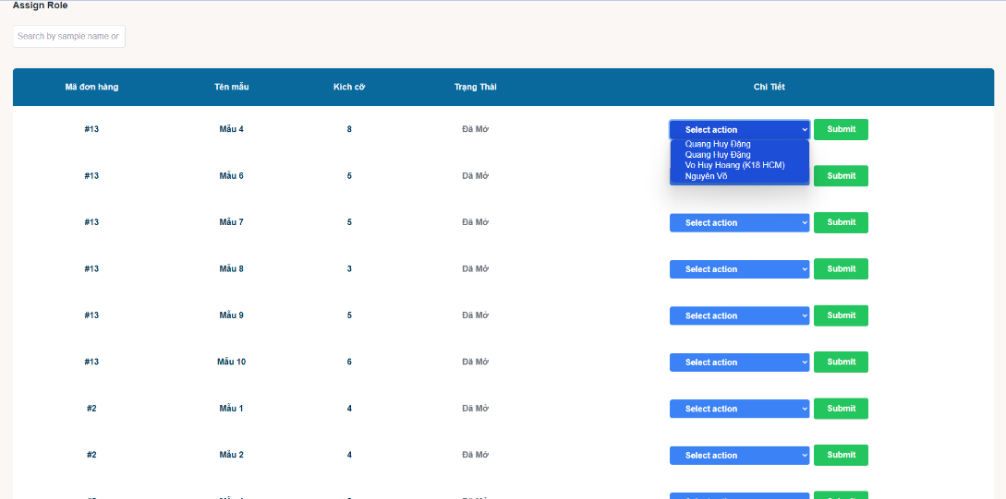

**Function Details:**

* **Task Selection:** Managers can choose tasks from the available list.
* **Staff Assignment:** Managers can select staff members to assign tasks to.
* **Deadline Setting:** Managers can set deadlines for tasks.
* **Notes:** Managers can provide additional instructions or details for the assigned tasks.
* **Validation:** Ensure all required fields are filled out correctly before submission.

### d. Manage Assessment Services Page

**Function Trigger:** Accessed when a manager logs in to their account or navigates to the "Manage Pricing & Timelines" page.

**Function Description:**

* **Actors/Roles:** Managers.
* **Purpose:** Enable managers to manage assessment services, including adding, editing, and deleting services.
* **Interface:** List layout displaying available services with options to edit or add new services.
* **Data Processing:** Input validation, data submission to the database, and updating the list of services.

**Screen layout:**

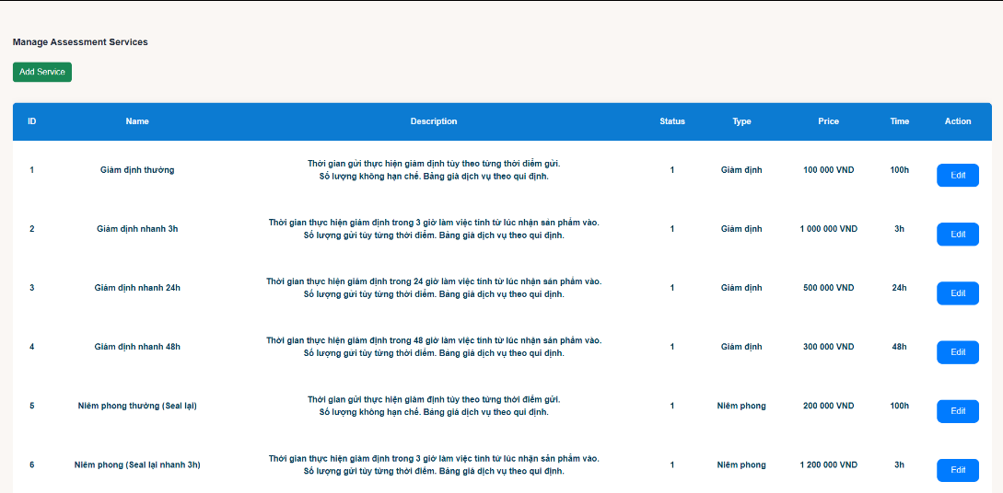

**Function Details:**

* **Service List:**
  + Display a list of services with details such as ID, name, description, status, type, price, and time.
  + Each service has an "Edit" button to modify its details**.**
  + The "Add Service" button allows the addition of new services.
* **Service Details:**
  + **ID:** Unique identifier for each service.
  + **Name:** Name of the service.
  + **Description:** Detailed information about the service.
  + **Status:** Current status of the service (e.g., active, inactive).
  + **Type:** Category of the service (e.g., Giám định, Niêm phong, Khác).
  + **Price:** Cost of the service, displayed with thousand separators for betterreadability.
  + **Time:** Time required to complete the service.
* **Add/Edit Service Modal:**
  + **Name**: Input field for the service name.
  + **Description**: Textarea for detailed information about the service.
  + **Status**: Input field for the service status.
  + **Type**: Dropdown to select the service type (e.g., Giám định, Niêm phong, Khác).
  + **Price**: Input field for the service price with automatic formatting to include thousand separators.
  + **Time**: Input field for the time required to complete the service.
* **Validation:**
  + Ensure all required fields are filled out correctly before submission.
  + Confirm action before saving changes or adding new services.
* **Data Submission:**
  + Submit the data to the backend for processing and storage.
  + Reload the data to reflect the latest updates after a successful submission.

# III. Database Design

## 1. Database Schema

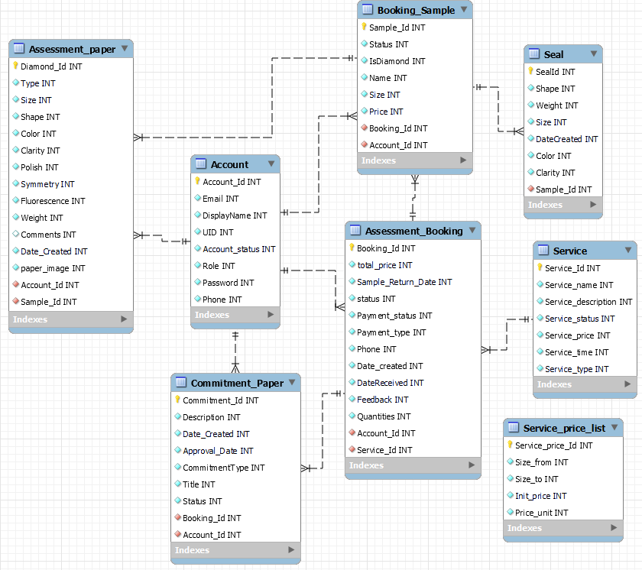

**Table Description**

|  |  |  |
| --- | --- | --- |
| **No** | **Table** | **Description** |
| 1 | Account | Stores user account details, including personal information and authentication tokens. |
| 2 | Seal | Records details of the sealing process for diamonds. |
| 3 | Assessment_Booking | Stores details about customers’ booking for assessment services. |
| 4 | Assessment Paper | Contains detailed assessment information for each sample. |
| 5 | Booking Detail | Stores details of booking samples made by customers |
| 6 | Commitment Paper | Records commitment papers related to assessment bookings |
| 7 | Service Price List | Stores the price list for different services offered. |
| 8 | Service | Stores details of services offered for diamond assessment |

## 2. Table Detail

**Account**

|  |  |  |  |  |  |  |  |
| --- | --- | --- | --- | --- | --- | --- | --- |
| **#** | **Field name** | **Type** | **Size** | **Unique** | **Not Null** | **PK/FK** | **Notes** |
| 1 | Account_Id | INT |  | Yes | Yes | PK | Unique identifier |
| 2 | Uid | STRING |  | Yes | Yes |  | Unique user ID |
| 3 | Email | STRING |  | Yes | Yes |  | Email address |
| 4 | Display_name | STRING |  |  | Yes |  | Display name |
| 5 | Account_status | INT |  |  | Yes |  | Status of account |
| 6 | Role | INT |  |  | Yes |  | Role/access level |
| 7 | Password | INT |  |  | Yes |  | Password |
| 8 | Phone | INT |  |  |  |  | Phone number |

**Assessment_Booking**

|  |  |  |  |  |  |  |  |
| --- | --- | --- | --- | --- | --- | --- | --- |
| **#** | **Field name** | **Type** | **Size** | **Unique** | **Not Null** | **PK/FK** | **Notes** |
| 1 | Booking_Id | INT |  | Yes | Yes | PK | Unique identifier |
| 2 | total_price | INT |  |  |  |  | Total price |
| 3 | Sample_Return_Date | INT |  |  |  |  | Sample return date |
| 4 | status | INT |  |  |  |  | Status |
| 5 | Payment_status | INT |  |  |  |  | Payment status |
| 6 | Payment_type | INT |  |  |  |  | Payment type |
| 7 | Phone | INT |  |  |  |  | Phone number |
| 8 | Date_created | INT |  |  |  |  | Date created |
| 9 | DateReceived | INT |  |  |  |  | Date received |
| 10 | Feedback | INT |  |  |  |  | Feedback |
| 11 | Quantities | INT |  |  |  |  | Quantities |
| 12 | Account_Id | INT |  |  |  | FK | Foreign key to Account |
| 13 | Service_Id | INT |  |  |  | FK | Foreign key to Service |

**Assessment_Paper**

|  |  |  |  |  |  |  |  |
| --- | --- | --- | --- | --- | --- | --- | --- |
| **#** | **Field name** | **Type** | **Size** | **Unique** | **Not Null** | **PK/FK** | **Notes** |
| 1 | Diamond_Id | INT |  | Yes | Yes | PK | Unique identifier |
| 2 | Type | INT |  |  |  |  | Type |
| 3 | Size | INT |  |  |  |  | Size |
| 4 | Shape | INT |  |  |  |  | Shape |
| 5 | Color | INT |  |  |  |  | Color |
| 6 | Clarity | INT |  |  |  |  | Clarity |
| 7 | Polish | INT |  |  |  |  | Polish |
| 8 | Symmetry | INT |  |  |  |  | Symmetry |
| 9 | Fluorescence | INT |  |  |  |  | Fluorescence |
| 10 | Weight | INT |  |  |  |  | Weight |
| 11 | Date_Created | INT |  |  |  |  | Date created |
| 12 | paper_image | INT |  |  |  |  | Paper image |
| 13 | Comments | INT |  |  |  |  | Comments |
| 14 | Account_Id | INT |  |  |  | FK | Foreign key to Account |
| 15 | Sample_Id | INT |  |  |  | FK | Foreign key to Sample |

**Seal**

|  |  |  |  |  |  |  |  |
| --- | --- | --- | --- | --- | --- | --- | --- |
| **#** | **Field name** | **Type** | **Size** | **Unique** | **Not Null** | **PK/FK** | **Notes** |
| 1 | SealId | INT |  | Yes | Yes | PK | Unique identifier |
| 2 | Shape | INT |  |  |  |  | Shape |
| 3 | Weight | INT |  |  |  |  | Weight |
| 4 | Size | INT |  |  |  |  | Size |
| 5 | DateCreated | INT |  |  |  |  | Date created |
| 6 | Color | INT |  |  |  |  | Color |
| 7 | Clarity | INT |  |  |  |  | Clarity |
| 8 | Sample_Id | INT |  |  |  | FK | Foreign key to Sample |

**Booking_Sample**

|  |  |  |  |  |  |  |  |
| --- | --- | --- | --- | --- | --- | --- | --- |
| **#** | **Field name** | **Type** | **Size** | **Unique** | **Not Null** | **PK/FK** | **Notes** |
| 1 | Sample_Id | INT |  | Yes | Yes | PK | Unique identifier |
| 2 | Status | INT |  |  |  |  | Status |
| 3 | IsDiamond | INT |  |  |  |  | Is diamond flag |
| 4 | Name | INT |  |  |  |  | Name |
| 5 | Size | INT |  |  |  |  | Size |
| 6 | Price | INT |  |  |  |  | Price |
| 7 | Booking_Id | INT |  |  |  | FK | Foreign key to Booking |
| 8 | Account_Id | INT |  |  |  | FK | Foreign key to Account |

**Commitment_Paper**

|  |  |  |  |  |  |  |  |
| --- | --- | --- | --- | --- | --- | --- | --- |
| **#** | **Field name** | **Type** | **Size** | **Unique** | **Not Null** | **PK/FK** | **Notes** |
| 1 | Commitment_Id | INT |  | Yes | Yes | PK | Unique identifier |
| 2 | Description | INT |  |  |  |  | Description |
| 3 | Date_Created | INT |  |  |  |  | Date created |
| 4 | Approval_Date | INT |  |  |  |  | Approval date |
| 5 | CommitmentType | INT |  |  |  |  | Commitment type |
| 6 | Title | INT |  |  |  |  | Title |
| 7 | Status | INT |  |  |  |  | Status |
| 8 | Booking_Id | INT |  |  |  | FK | Foreign key to Booking |
| 9 | Account_Id | INT |  |  |  | FK | Foreign key to Account |

**Service_Price_List**

|  |  |  |  |  |  |  |  |
| --- | --- | --- | --- | --- | --- | --- | --- |
| **#** | **Field name** | **Type** | **Size** | **Unique** | **Not Null** | **PK/FK** | **Notes** |
| 1 | Service_price_Id | INT |  | Yes | Yes | PK | Unique identifier |
| 2 | Size_from | INT |  |  |  |  | Size from |
| 3 | Size_to | INT |  |  |  |  | Size to |
| 4 | Init_price | INT |  |  |  |  | Initial price |
| 5 | Price_unit | INT |  |  |  |  | Price unit |
| 6 | Service_Id | INT |  |  |  | FK | Foreign key to Service |

**Service**

|  |  |  |  |  |  |  |  |
| --- | --- | --- | --- | --- | --- | --- | --- |
| **#** | **Field name** | **Type** | **Size** | **Unique** | **Not Null** | **PK/FK** | **Notes** |
| 1 | Service_Id | INT |  | Yes | Yes | PK | Unique identifier |
| 2 | Service_name | INT |  |  |  |  | Service name |
| 3 | Service_description | INT |  |  |  |  | Service description |
| 4 | Service_status | INT |  |  |  |  | Service status |
| 5 | Service_price | INT |  |  |  |  | Service price |
| 6 | Service_time | INT |  |  |  |  | Service time |
| 7 | Service_type | INT |  |  |  |  | Service type |